**Categorizing and prioritizing information for your website outline**

After you have a prioritized list of user and business-driven content and features, translate them into an old-fashioned outline. This outline ultimately helps you build a sitemap.

The key to producing a successful outline is your ability to group similar items and features together. As you become more familiar with the list of content and features, a pattern begins to emerge. Some items go together quite easily, whereas other ideas don’t fit in at all.

Here are the steps for converting your prioritized requirements list into a workable outline:

1. **Group ideas together.**

Find features and content that seem similar and place them next to each other.

Think of each entry within a group as one web page of content.

1. **Limit the number of groups to 5–7.**

For usability reasons, identify no more than 5–7 main groups. If you find that difficult to do (as it may be with larger websites), you may identify up to three sets of groups, prioritized as primary, secondary, and tertiary sets.

1. **Limit the depth of each group to just two levels.**

Within each group, you will have a list of items. In some cases, you’ll have subcategories of a particular item. For usability reasons, limit yourself to just one additional level of subcategorization. If you get any deeper than this, and have subcategories *of* subcategories, you run into navigation design challenges. Following is an example of two levels of depth within the About the Company group. Notice the numbering scheme:

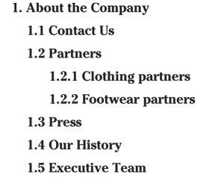

1. **4. Group global features into their own set.**

If the list of requirements contains tools like a member login or a search function, or mandated pages like privacy policy or terms of use, set them aside into a “Globals” group, as in the following example. Do not count this Globals group in the limited number of five to seven content groups. Tools and links to pages such as these will ultimately find a happy home either in the header or footer of your website.

Well this point should be pretty easy. What do you want to make your website about? Now then think about who you want to visit your website. Remember you should try to think of people that are going to want to read, see or buy what ever you have on the site. For example, if you’re making a site on sports, narrow down what type of person will want to go to your site by what you are going to have in it. If you have general information about various sports, it would be helpful to people who might be about to join a certain sport and have no idea what to expect. So you might try to cater to them or another group of people that you can think of. Also you should take note of the form that your going to present your information. Are you going to write articles, tutorials, show pictures, videos, etc to get your objective across? Once you’ve finished thinking about all that write it down and move on to the next step.

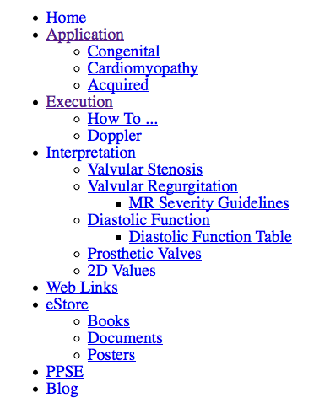

**Navigation**  
This is probably the most important part of planning your website. If your navigation system is too cumbersome, then no one is going to go through the trouble of visiting your site. When developing your navigation you must make 2 decisions. The first is what you’re going to use to link to each page and the second is how the links will be arranged. You can use text links, buttons, pop-ups, frames, iframes or a slew of other systems to link to other pages. Next you have to choose the organization structure. The three major organization structures are linear, hierarchy, and random. Most sites generally use a combination of all three types.

**Linear**  
Linear navigation is where one page links to just one other page. It’s similar to how a PowerPoint presentation works. This type of website is best for online comic book sites and presentations.

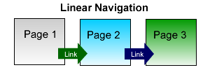

**ierarchy**  
A hierarchy structure is when one page links to a few pages which in turn link to several others. For example major directory sites uses an hierarchy structure to categorize websites. This system is best suited for directories, information websites (depending on the size of the site) and certain shopping sites.

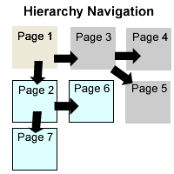

**Random**  
A random navigation structure is one where you can get to any page on the entire website from any page on the website. This system is best for search engines and smaller websites. However, keep in mind that a small search function is a nice addition to nearly any website.

